Extinction Rates in Turtles Based on Habitat Type

Evolution 461

Final Paper

Lauren Oxford

1 May 2020

**Introduction**

It is no secret that the population of certain turtle species are seeing decreasing numbers of individuals and the causes can be traced back to many factors. The decline can be explained by habitat destruction, climate change, turtles being used for food and as pets, and the many diseases that kill them. The most troubling, but a factor that we as humans can fix, is to help protect these turtle’s habitats.

The inspiration for this paper was because of the *Gopherus agassizi*i (Desert Tortoises) of the Mojave Desert and how their population decline has been caused by construction and residential development in their habitat. The Mojave Desert is a landscape that consumes Southern California, Southern Nevada, and little bit of Western Arizona. The plans for the future involve large amounts of renewable energy. Specifically, the Mojave Desert because it is a great place for sources like solar and wind energy. Over the next 50 years, the western United States government officials have plans to develop broad scale projects such as the Desert Renewable Energy Conservation Plan (Farnsworth et al. 2015).This project like many others seen around the world causes great destruction for the natural habitats for many turtles and tortoises like the *Gopherus agassizi*i.

In recent years, the world has seen an increase in human population and urbanization. According to the Our World In Data article “Urbanization”, four billion people live in urban areas globally as of 2017 (Ritchie and Roser 2018). Most Urban areas are cities on the coast of countries. These coasts are home to many turtles species and because of the population increase there has been a decline in turtle populations. *Malaclemys terrapin* (Diamondback turtles) in the Carolinas have seen habitat destruction because the coast is a huge industry for tourism and people’s houses. The Diamondback turtle has also been a source of food for people for many years destroying their populations (Converse et al. 2017).

The purpose of this paper is to explore the evolutionary hypothesis that the extinction rates of turtles are directly correlated to their habitat type. I will explore data for many species of turtles and their habitat types. To answer the questions of how population decline is affecting the evolutionary development of turtles and how a population regains its numbers after reaching an endangered or extinct rating.

**Materials & Methods**

Data was collected from two different sources, the official website of the International Union for Conservation of Nature and the Our World In Data website, specifically an article called “Urbanization”. The International Union for Conservation of Nature (IUCN) Red List of Threatened Species is the global standard for threat assessments and determination of conservation status of all species of animals and plants on Earth (ANDERS 2018).The data pulled for this paper is the IUCN ratings for the 260 species of turtles or tortoises and data has been collected since the 1980s. The IUCN rating is divided into eight different levels, which include: vulnerable, critical, threatened, low risk, least concern, endangered, extinct, and data deficient. Out of the 260 species 69 of them have a vulnerable rating, 50 of them have a critical rating, 14 of them have a threatened rating, 31 have a low risk rating, 36 have a least concern rating, 44 of them have an endangered rating, 9 of them are extinct, and 12 of them have a data deficient rating. Another way that the IUCN organizes their data is separating the species habitats into realms. There are eight realms on this planet and turtles occupy six of them. These realms include the Nearctic, Afrotropical, Australasian, Neotropical, Palearctic, and Indomalayan. The Nearctic realm is a biographical realm that covers most of North America including: Greenland, Central Florida, and the highlands of Mexico. In the data collected from the IUCN, the Nearctic realm houses 54 species of turtle. The Afrotropical realm covers the majority of the Arabian Peninsula, African South, the Sahara Desert, Madagascar, southern Iran, southwestern Pakistan, and the western islands of the Indian Ocean. According to the IUCN, it is home to 43 species of turtle. The Australasian realm covers Australia, New Zealand, and surrounding small islands. The IUCN says that it is home to 13 species of turtle. The Neotropical realm covers the entire South American temperate zone and it is home to 67 species of turtle. The Palearctic realm covers Europe, Asia (north of the Himalaya foothills), northern Africa, and the northern parts of the Arabian Peninsula. In this realm 15 species of turtle call it home. Finally, the Indomalayan realm covers South and Southeast Asia, it is home to 67 species. Each realm can have species specific to them or there are species that are located in multiple realms.

The second source that data was collected from is the official website of Our World In Data. The article “Urbanization” written by Ritchie, Hannah, and Max Roser focuses on the urbanization of the world using population rates. The data has been collected from 1960 through 2017 with only a few countries without data. The data was used to make figure 2, a line graph showing the urban population increase since 1960. Figure 1 was taken from the article and used to provide a visual of the world and urban increase.

To make figure 2 and figure 3, a coding system and language of R was used. The line graph was made using a package called ggplot2. The data was downloaded using a .csv and input into a plot using ggplot and geom_line. For the bar graph, a .csv was also used to download the data from the IUCN into R. I made each realm a variable in the graph and used barplot to make the graph (R Core Team 2019).

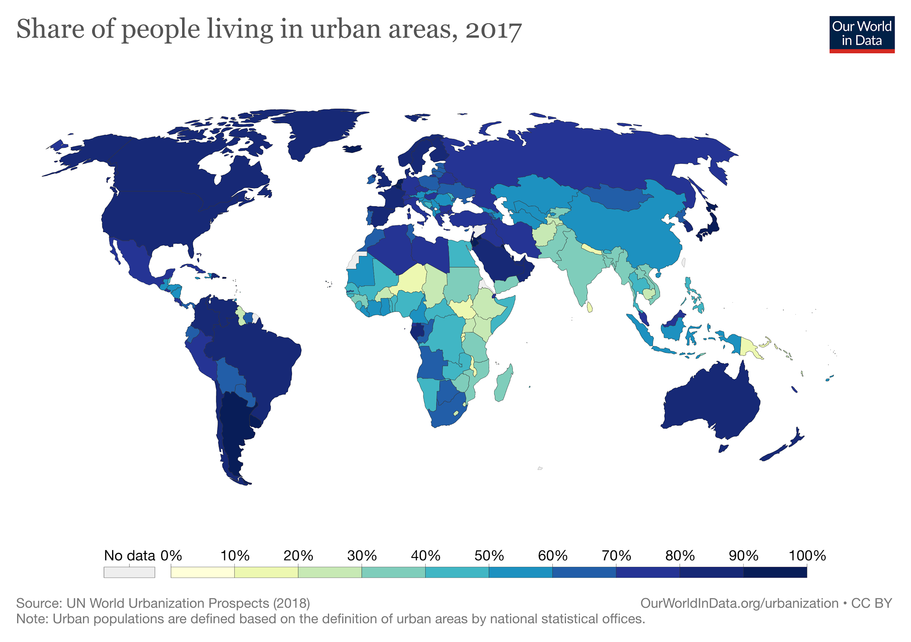

Figure 1: The graph above shows the percent ratings of population growth in every country around the world. The darker the color (navy), the more people live in urbanized areas in that country. The lighter the color (yellowish), the less people live in urbanized areas in that country. (Ritchie and Roser 2018)

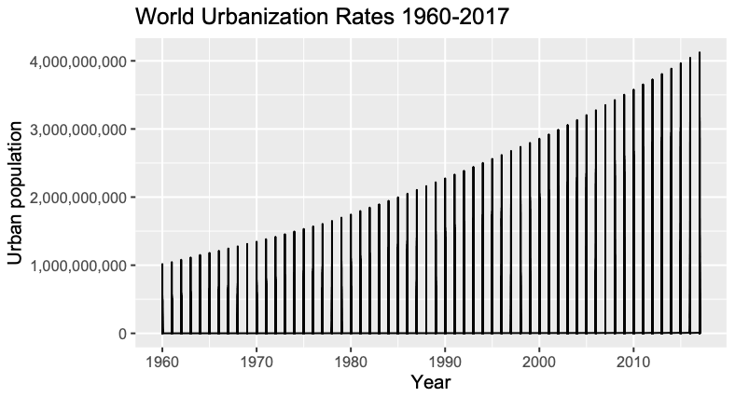

Figure 2: The graph above shows the population increase in urban areas around the world from 1960-2017. The increase is by the billions and will continue to increase in future years and generations. (Ritchie and Roser 2018)

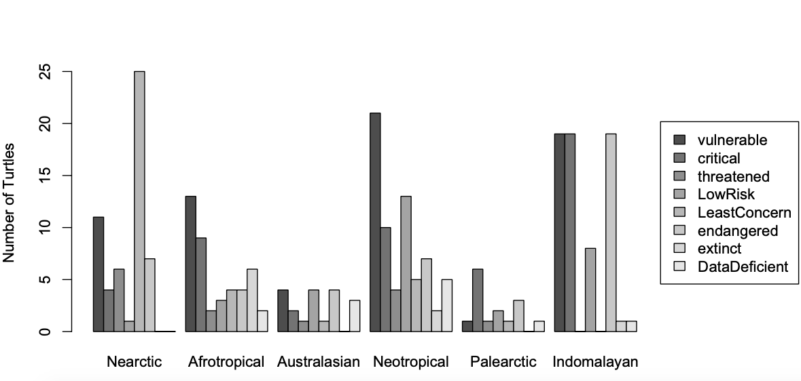

Figure 3: The bar graph above uses data from the IUCN Red List Ratings of about 260 turtles species found around the world. The IUCN breaks up the species habitats into realms and those are represented on the x-axis. The bars themselves represent the red list category that each turtle rates at based on their population in each realm. The rating include: vulnerable, critical, threatened, low risk, least concern, endangered, extinct, and data deficient ([https://www.iucnredlist.org](https://www.iucnredlist.org/search/list))

The data shown in figure 2, is the population of the world starting in 1960 through 2017. The line graph is displaying a dramatic increase in urbanization around the world from one billion to 4 billion in just over 50 years. This increase will and has affected everything on our planet including turtle populations. Figure 1 is using the same data as figure 2, but it is showing the percent rates of increase in each country around the world. I did not make figure 1, but it is a good visualization of urbanization of important realms that turtles species like to call home. Each realm has increased majorly and this is a correlation to population decline in turtles. The Nearctic, Australasian, Neotropical, and Indomaylan realms are home to many turtle species and figure 1 shows that there is a correlation with human urban population increase and turtle decline.

The results of figure 3 show that 260 species of turtle assets by the IUCN are mostly decreasing in population size. Figure 3 shows that the Nearctic has turtles with mostly an endangered red list category rating, with moderate vulnerable, threatened, and extinct ratings. In the Afrotropical realm rates are high with species at vulnerable and critical ratings, with the other categories topping at seven species. The Australasian realm has little data with some vulnerable, low risk, and extinct species. This tells me that the region of Australia and New Zealand either do not have a lot of species of turtle or the area is properly explored and examined. The Neotropical area in the graph above, most species are rated vulnerable with high numbers in threatened and critical. This realm has highest species diversification compared to the other realms in the IUCN dataset. The Palearctic realm covers the most area and has a small number of species of turtle. The turtles that do live in this realm rate mostly as critical. The Indomalayan realm has the second highest species diversification according to this data. The graph shows that most of the turtles show high ratings in the vulnerable, critical, and extinct categories.

**Discussion**

The biogeological realms of this world actually amount to 8, but turtles only live in 6 realms. The realms that the turtles do occupy include the Nearctic, Afrotropical, Australasian, Neotropical, Palearctic, and Indomalayan. These realms may play a huge role in the decreasing populations of the turtles that live in them. The Nearctic is most of North America and that includes the United States. We as a country can do a lot better when it comes to protecting species and their habitats. Species like Diamondbacks and the Desert Tortoise are losing their habitats because of residential construction in unnecessary areas. The Neotropical realm or most of South America, has also seen decreasing populations because of over populated beaches, tourism, and climate change. The Indomalayan realm or the South Eastern Asian countries have many species that are endangered or extinct and this is because of over exploitation as food and over populated beaches. The real interesting realm is the Australasian because they have many species that we do not have data for in the IUCN. Countries like Australia, the Philippines, and Japan can do better when it comes to learning about the species of turtles that live in these areas.

The decline in population affects the evolution of turtles because the pool of genes is greatly decreased. The rules that the best fit or the survival of the fittest go out the window because the causes of decline stem from climate change, habitat destruction, and being used as pets or food. Turtles have been on this planet for a long time and now they are one of the most threatened groups of vertebrates on this planet. In time, there will be phylogenetic effects on species who are endangered, threatened, critical or vulnerable. They will evolve differently than before just to survive and make new generations because gene flow is lower and drift has increased.

To answer the hypothesis that turtle extinction rates are directly correlated with habitat type is true because most habitats are being affected by human urbanization. Turtles are among the most imperiled vertebrates on the planet, and Asia is at the epicenter of the global turtle extinction crisis that has recently and rapidly developed as a result of the unsustainable trade that began as the Asian Turtle Crisis (ANDERS 2018). The factors that have caused turtle population decline have an epicenter as well. The epicenter is humans and our ability to take over a space and cause an unbalance. We have the ability to destroy their habitat, help spread disease, consume them, use them as pets, and cause climate change. We also have the ability to reverse all of those factors. This opinion is biased and colors my ability to interpret the data because I have hope that we can save each endangered or threatened species. There are also problems with most data because it is very difficult to count every individual turtle. Some species of turtles do not have data because of our ability to reach their habitat or there is so little of them left we can not find them. In recent years, some species of turtle that have been rated as endangered or near extinction have many recoveries. This is typically seen in marine turtles because the cause is felt in many people's hearts. Conservation organizations and helpful individuals have made it their missions to help these marine turtles and save their population. Governments and laws have also been established in order to save some turtles species. All amazing things are happening to help save turtles and it may be a slow mission but in time it will do great for ecosystems and coastline environments.

**References**

ANDERS G.J. RHODIN1, CRAIG B. STANFOR , PETER PAUL VAN DIJK, (PDF) “Global

Conservation Status of Turtles and Tortoises (Order Testudines).” n.d.

ResearchGate. (2018) Accessed April 30, 2020. <http://dx.doi.org/10.2744/CCB-1348.1>.

Converse, Paul E., Shawn R. Kuchta, J. Susanne Hauswaldt, and Willem M. Roosenburg. 2017.

“Turtle Soup, Prohibition, and the Population Genetic Structure of Diamondback

Terrapins (Malaclemys Terrapin).” Edited by Tzen-Yuh Chiang. *PLOS ONE* 12 (8):

e0181898. <https://doi.org/10.1371/journal.pone.0181898>.

Farnsworth, Matthew L., Brett G. Dickson, Luke J. Zachmann, Ericka E. Hegeman, Amanda R.

Cangelosi, Thomas G. Jackson, and Amanda F. Scheib. 2015. “Short-Term Space-Use

Patterns of Translocated Mojave Desert Tortoise in Southern California.” Edited by Jesus E. Maldonado. *PLOS ONE* 10 (9): e0134250.

<https://doi.org/10.1371/journal.pone.0134250>.

“The IUCN Red List of Threatened Species.” *IUCN Red List of Threatened Species*,

International Union for Conservation of Nature and Natural Resources, 2020,

[www.iucnredlist.org/](http://www.iucnredlist.org/).

R Core Team (2019). R: A language and environment for statistical computing. R Foundation for

Statistical Computing, Vienna, Austria. [https://www.R-project.org/](https://www.r-project.org/).

Ritchie, Hannah, and Max Roser. 2018. “Urbanization.” *Our World in Data*, June.

<https://ourworldindata.org/urbanization>.